Extended reality (XR)
A project report submitted for
Information technology
By
Harshita suyal
Under the guidance of
Praveen Kumar Joshi Sir

Ever green sr. sec. school
(Governed by educational welfare society)
Tularampur -223139, District -Nainital
Uttarakhand ,India
October -2021
Certificate
This is certify that the project entitled “Extended reality”being submitted to Ever Green Sr. Sec. School, Haldwani for the project work of Information technology is a record of work carried by MR Praveen Joshi under my guidance and supervision
Date 4/October /21

Supervisor
Mr
PraveenJoshi
TGT
Computer
EG Haldwani
Abstract.
Extended Reality (XR) is an Umbrella term encapsulation Augmented Reality (AR),real and virtual combined Environment and human machine Interaction generated by computer technology and werable where X represent a variable for any current or future spatial computer technology.
Acknowledgement
I would like to express my most heartfelt gratitude and respect to my Supervisor Mr Praveen Joshi, for suggestion The topic ofmy project workand for his Excellent guidance valuable suggestions and endless support throughout the course of my preparing the report I am greatly indebted for his construction suggestion and from time to time during the progress of my work.
Harshita suyal
Table of contents
 | Certificate
 | Acknowledgement
 | Absact
1 | Extended Reality
2 | Major challenge Faced by compain Developing Extended Reality
3 | Application of Extended Reality
4 | Powerful Real World application

Introduction
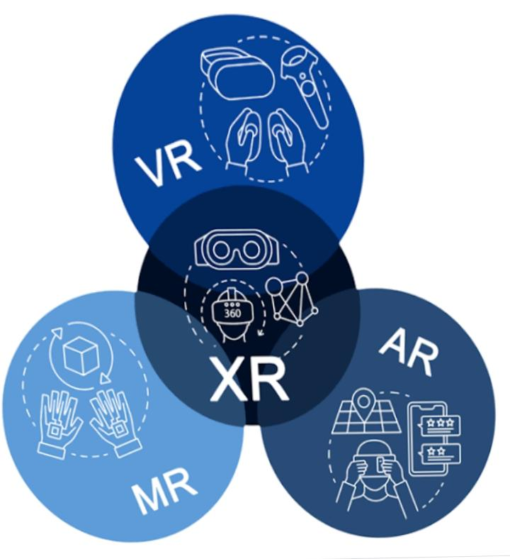
What is extend reality?
Extended reality is our term referring to all real and vertical combinat environment and human Interaction generated by computer technology and beer exit represent a variable for any current or future computing technologies.
Example It include representativeform such as mixed reality and vertically reality.
- Major challenge faced by developing extended reality
- Hardware – Developing the hardware of XR device is also a challenge of campanies in the field .Since a lot of of technologies software and compounds are being used making hardware is a difficulty task.
- Privacy- Privany to is a challenge will be faced both by the user as well as the companies since XR device are required to create an environment based on the user requirement a lot of prevent detail mind be needed to create our usual rich environment.
- Application of extended reality
- Entertainment industry- the entertainment industry hugley benefit for XR are just the same way they are benefiting from AR &VR.
- Sales and marketing-Campaign can advised their protect via XR & can give their user our hand on expiration about their product or service.
- Education and training- the use of XR be a bone for the interest rate student all across “Extended reality”

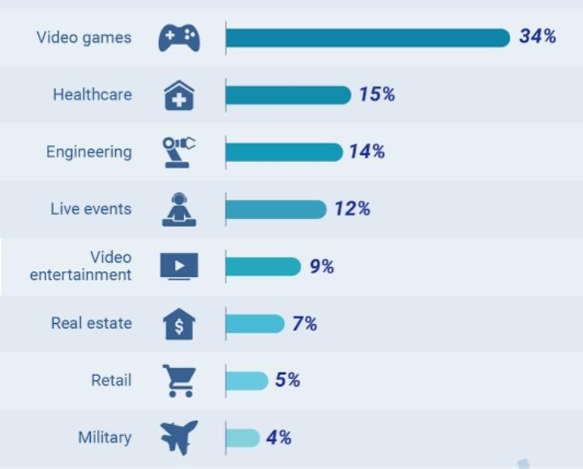

- Powerful real world application
The narket off extend reality is expected to have a compound annual growth rate of more than 65% during the periods of 2019 -2024
- Entertainment and gaming-The entertainment and video game industries are the mforemost user of Extended Reality .Camera tracking and real time create an vertically environment align to get the real feal of sense
- Employes and Consumers -Replacing physical manuals, Extended Reality can take techniques focoves fo on the tags without having to flip the page of manual.

